Assignment 12

R-6.1 Draw a simple undirected graph G that has 12 vertices, 18 edges, and 3 connected components. Why would it be impossible to draw G with 3 connected components if G had 66 edges?

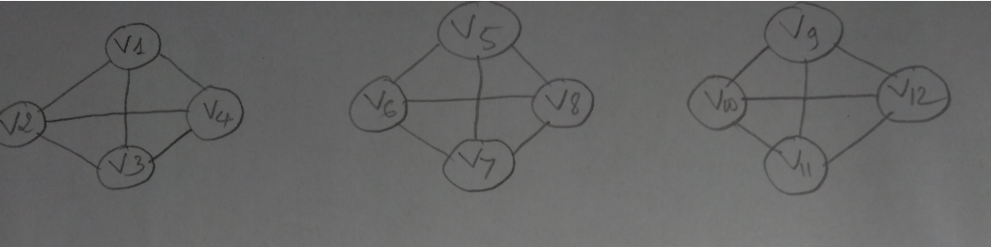

We have the formular: m <= n(n-1)/2, m: number of edges and n is number of vetices. Because G must have 3 connected components, we have 2 cases:

1. Component 1: 1 vertex, Component 2: 1 vertex, Component 3: 10 vertex

Applying the formular above, we have n(n-1)/2 = 10(10-1)/2 = 45 > m = 66

Therefore, these 3 connected components can not use 66 edges

1. Component 1: 2 vertex, Component 2: 2 vertex, Component 3: 8 vertex

The same formulars ass above, we have total of edges is 1 + 1 + 8(8-1)/2 = 26 edges < m = 66 edges

Therefore, G can NOT be drawn a graph with 66 edges and 12 vertices

R-6.4 Bob loves foreign languages and wants to plan his course schedule to take the following nine language courses: LA15, LA16, LA22, LA31, LA32, LA126, LA127, LA141, and LA169. The course prerequisites are:

• LA15: (none)

• LA16: LA15

• LA22: (none)

• LA31: LA15

• LA32: LA16, LA31

• LA126: LA22, LA32

• LA127: LA16

• LA141: LA22, LA16

• LA169: LA32

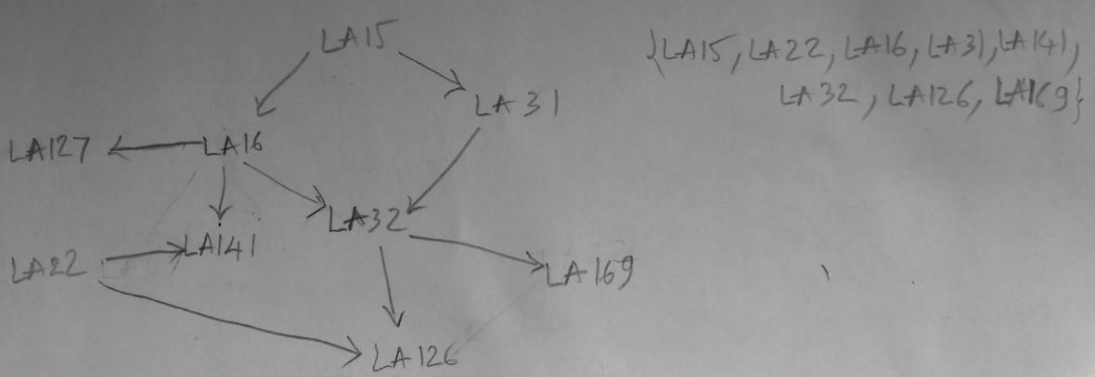

R-6.7 Would you use the adjacency list structure or the adjacency matrix structure in each of the following cases? Justify your choice.

a. The graph has 10,000 vertices and 20,000 edges, and it is important to use as little space as possible.

🡪 The adjacency list structure is preferable. Indeed, the adjacency matrix structure wastes a lot of space. It allocates entries for 100,000,000 edges while the graph has only 20,000 edges.

b. The graph has 10,000 vertices and 20,000,000 edges, and it is important to use as little space as possible.

🡪 Adjacency matrix, since this graph is dense, i.e., its number of edges is of the order of the maximum possible number of edges in that graph (which is about 50,000,000)

c. You need to answer the query areAdjacent as fast as possible, no matter how much space you use.

🡪 Adjacency matrix, since looking up the adjacency is done in constant time.